**PROJECT REPORT**

**REAL TIME COMMUNICATION SYSTEM POWERED BY AI FOR SPECIALLY ABLED**

**R. SARANYA (952419104029)**

**A. SELVATHI (952419104031)**

**G. YOGESHWARI (952419104037)**

**B. RAJESHWARI (952419104025)**

In partial fulfilment for the award of the degree

OF

BACHELOR OF ENGINNERING

IN

COMPUTER SCIENCE AND ENGINEERING



PSN INSTITUTE OF TECHNOLOGY AND SCIENCE

ANNAUNIVERSITY: CHENNAI 600 025

MARCH 2022

Contents

**1.**Introduction

* 1. Problem statement
  2. Purpose

1. Literature survey
   1. literature survey format
   2. literature survey1
2. Prerequisites
3. Data collection
   1. train. Set
   2. test. Set
4. Image pre-processing
   1. Image data generator
   2. Apply image data generator train and test set
   3. import image data generator library and configure it
5. Model building
   1. Add the convolution layer
   2. Add the dense layer
   3. Add the flitter layer
   4. Add the pooling layer
   5. Compile the model
   6. Fit and save the model
   7. Import the required model building libraries
   8. Initialize the model
   9. Test the model
   10. Import the packages and load the save the model
   11. load the test images pre-processing it and predict
6. Application building
   1. Building html page
      1. html page
      2. output
   2. Building block application part3
      1. Camera
      2. Main.pdf
   3. Flask application
      1. Banner heading image
      2. Index
      3. Navbar cantered brand
7. Train CNN model on IBM first milestone
   1. Train image classification model
      1. Model training
      2. Model testing
   2. IBM cloud
8. Ideation phase
   1. Brainstorm
   2. Empathy map
   3. literature survey
   4. Project design phase-1
   5. Solution architecture
   6. Problem solution
   7. Proposed solution
9. Project design phase-2
   1. Customer journey
   2. Data flow diagram
   3. Technology architecture
   4. Technology stack
10. Project planning phase
    1. milestone activity plan
    2. Sprit delivery plan
11. Project delivery phase
    1. Project development delivery of sprit-1
    2. Project development delivery of sprit-2
    3. Project development delivery of sprit-3
    4. Project development delivery of sprit-4
12. Results
13. Conclusion

1.INTRODUCTION

## 1.1 Project Overview

In our society, we have people with disabilities. The technology is developing day by day but no significant developments are undertaken for the betterment of these people. Communications between deaf-mute and a normal person has always been a challenging task. It is very difficult for mute people to convey their message to normal people. Since normal people are not trained on hand sign language. In emergency times conveying their message is very difficult. The human hand has remained a popular choice to convey information in situations where other forms like speech cannot be used. Voice Conversion System with Hand Gesture Recognition and translation will be very useful to have a proper conversation between a normal person and an impaired person in any language.

## 1.2 Purpose

The project aims to develop a system that converts the sign language into a human hearing voice in the desired language to convey a message to normal people, as well as convert speech into understandable sign language for the deaf and dumb. We are making use of a convolution neural network to create a model that is trained on different hand gestures. An app is built which uses this model. This app enables deaf and dumb people to convey their information using signs which get converted to human-understandable language and speech is given as output.

# 2.LITERATURE SURVEY

## 2.1 Existing Problem

Artificial intelligence is not designed to replace humans but rather to enhance our lives by helping us do things we are unable to do on our own. Many companies are working on this type of research, including Google Deep mind, IBM Watson, Apple Siri, Microsoft Cortana, etc., which means there will likely be many new developments soon. These innovations could positively impact everyone’s life – even those without disabilities – because they make everyday tasks easier and less time-consuming.

## 2.2 References 1) A Signer Independent Sign Language Recognition with Coarticulation Elimination from Live Videos: an Indian Scenario P.K. Athira, C.J. Sruthi, A. Lijiya (2019)

Advantage: Economical can be implemented with a mobile camera which makes it very user-friendly.

Disadvantage: Not efficient under cluttered backgrounds and different illumination conditions.

2) White, J.J.: Fairness of AI for people with disabilities: problem analysis and interdisciplinary collaboration. ACM SIGACCESS Access. Comput. 125, 1 (2020)

Much has been written about the potential of artificial intelligence (AI) to support, and even transform, the lives of disabled people. It is true that many advances have been made, ranging from robotic arms and other prosthetic limbs supported by AI, decision support tools to aid clinicians and the disabled themselves, and route planning software for those with visual impairment. Many individuals are benefiting from the use of such tools, improving our accessibility and changing lives. But what are the true limits of such tools? What are the ethics of allowing AI tools to suggest different courses of action, or aid in decision-making? And does AI ofter too much promise for individuals? I have recently undergone a life changing accident which has left me severely disabled, and together with my daughter who is blind, we shall explore the day-to-day realities of how AI can support, and frustrate, disabled people. From this, we will draw some conclusions as to how AI software and technology might best be developed in the future.

3**) A Deep Learning based Indian Sign Language Recognition System Sruthi C. J and Lijiya A (2019)**

Advantage: Training accuracy of 99.93% and with testing and validation accuracy of 98.64%. Disadvantage: Facial expression and context analysis are the other part not included.

**4) Bigham, J. P., Jayant, C., Miller, A., White, B., & Yeh, T. (2010, June). VizWiz::Locate It-enabling blind people to locate objects in their environment. In 2010 IEEE Computer Society Conference on Computer Vision and Pattern Recognition-Workshops (pp. 65-72). IEEE.**

The sixth sense is a multi-platform app for aiding the people in need that is people who are handicapped in the form of lack of speech (dumb), lack of hearing (deaf), lack of sight (blind), lack of judicial power to differentiate between objects (visual agnosia) and people suffering from autism (characterized by great difficulty in communicating and forming relationships with other people and in using language and abstract concepts). Our current implementation of the product is on two platforms, namely, mobile and a web app. The mobile app even works for object detection cases in offline mode. What we want to achieve using this is to make a better world for the people suffering from disabilities as well as an educational end for people with cognitive disabilities using our app. The current implementation deals with object recognition and text to speech and a speech to text converter. The speech to text converter and text to speech converter utilized the Web Speech API (Application Program Interface) for the website and text to speech and speech to text library for the mobile platform. The object recognition wouldn't fetch enough use out of a website. Hence, it has been implemented on the mobile app utilizing the Firebase ML tool kit and different pre-trained models, which are both available offline as well as online.

## 2.3 Problem Statement Definition

**Problem Statement (PS):**

People with disabilities are not able to communicate with the people and society. Though technologies are evolving but there is no significant growth for these people. So, an AI system is developed to communicate with people in real time.

**I am:**

(Specially abled person)

A Specially abled person, who finds difficulties in communicating with the people and couldn’t able to convey what they feel. And so, the talented ones not able to express what they feel.

**I’m trying to:**

(communicate with people)

Communicate with normal persons to convey the information which I intend to.

**But:**

(people find it difficult to understand)

I can't able to communicate easily with the people and they find it difficult to understand.

**Because:**

(they don’t understand hand signs)

Only few knows the hand sign language not most of the people knows. So, it is a problem that every impaired person has.

**Which makes me feel:**

(Anxiety, Lose confidence)

Frustrated, Lose confidence, Anxiety.

**3. IDEATION & PROPOSED SOLUTION**

### 3.1 Empathy Map Canvas

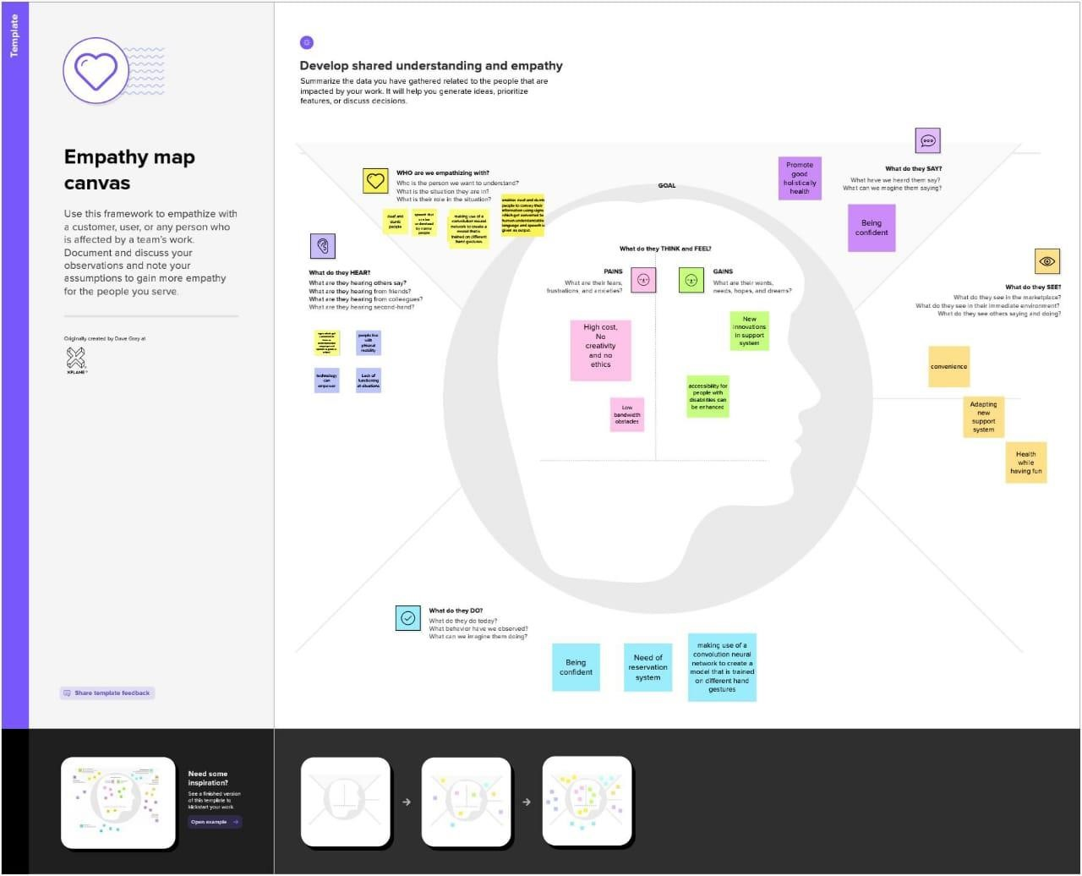

### 3.2 Ideation & Brainstorming

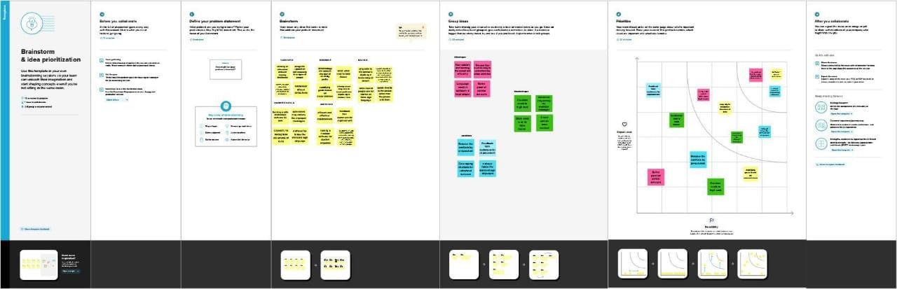

#### 3.3 Proposed Solution

|  |  |  |
| --- | --- | --- |
| **S.No.** | **Parameter** | **Description** |
| 1. | Problem Statement  (Problem to be solved) | An application for deaf and dumb people to convey their information using signs which get converted to human-understandable language and  speech in Artificial Intelligence |
| 2. | Idea / Solution description | By using Voice Conversion System with Hand Gesture Recognition and translation  will be very useful to have a proper conversation |
| 3. | Novelty / Uniqueness | We are using a convolution neural network to create a model that is trained on different hand gestures and  an app is built for the use this mode |
| 4. | Social Impact / Customer Satisfaction | Communicating with others and being connected in the society and remove accessibility barriers |
| 5. | Business Model (Revenue Model) | By Using: Better communication with the disabled and Financial  By Without Using: Can’t  Communicate and leads to loneliness |
| 6. | Scalability of the Solution | Enhance people with disabilities to step into a world where their are facing difficulties in communication |

3.4 Problem – Solution Fit

The Problem-Solution Fits simply means that you have found a problem with your customer and that the solution you have realized for it actually solves the customer’s problem. It helps entrepreneurs, marketers and corporate innovators identify behavioural patterns and recognize what would work and why

**Purpose:**

* Solve complex problems in a way that fits the state of your customers.
* Succeed faster and increase your solution adoption by tapping into existing mediums and channels of behaviour.
* Sharpen your communication and marketing strategy with the right triggers and messaging.
* Increase touch-points with your company by finding the right problem- behaviour fit and building trust by solving frequent annoyances, or urgent or costly problems.
* Understand the existing situation in order to improve it for your target group.

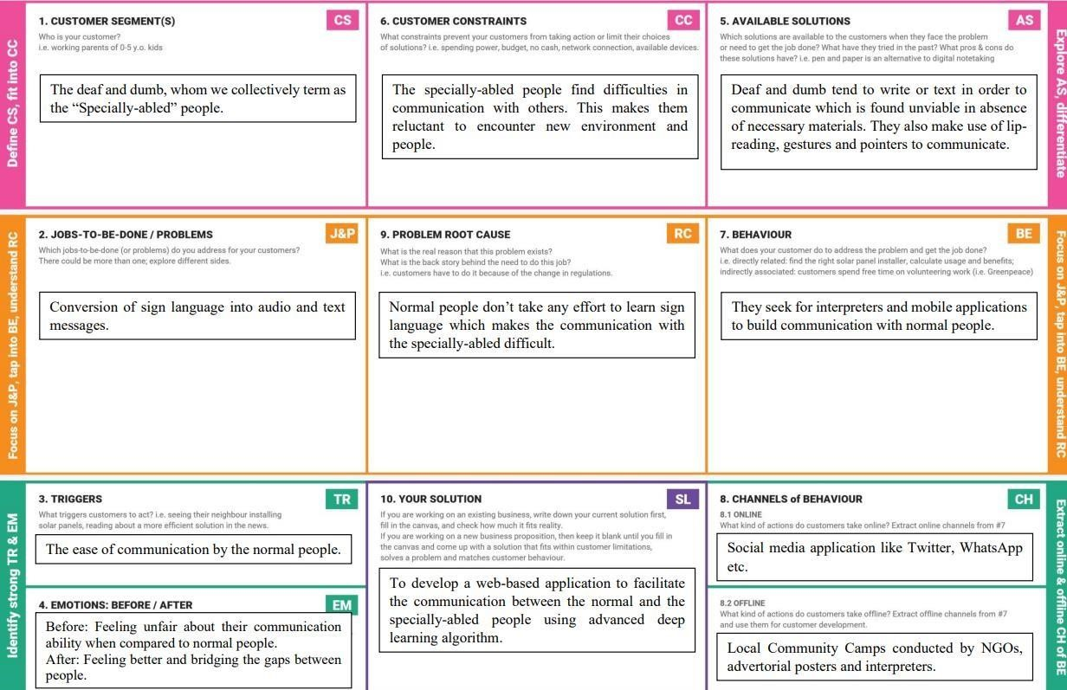

### 4. REQUIREMENT ANALYSIS

#### 4.1 Functional Requirement

Following are the functional requirements of the proposed solution.

|  |  |  |
| --- | --- | --- |
| **FR No.** | **Functional**  **Requirement (Epic)** | **Sub Requirement (Story / Sub-Task)** |
| FR-1 | User Registration | Registration through Form Registration through Gmail |
| FR-2 | User Confirmation | Confirmation via Email Confirmation via OTP |
| FR-3 | System | Desktop with high resolution camera. Provides Access to capture Image through the Camera. Provides Access to Upload the Captured image through Gallery. |
| FR-4 | Text conversion | Converts the Sign language into a text using Convolutional Neural Network (CNN) Model. |
| FR-5 | Sentence Translation | Recognizes the separate Signs of One-ByOne and it Could provide a Translation in the situation where Signed Extract System (SEE) is provided. |
| FR-6 | Review | Users Can Give their Feedback on the Review page about the Application. |

**4.2 Non-Functional Requirement**

Following are the non-functional requirements of the proposed solution.

|  |  |  |
| --- | --- | --- |
| **NFR No.** | **Non-Functional**  **Requirement** | **Description** |
| NFR- 1 | Usability | To convey a message to normal people, as well as convert speech into understandable sign language for the deaf and dumb people. |
| NFR- 2 | Security | Converted information using signs into speech is accessed only by the user. |
| NFR- 3 | Reliability | Sign Method is Relevant to use for Differently abled persons. |
| NFR- 4 | Performance | The time for converting signs into speech should be faster for the real time communication. |
| NFR- 5 | Availability | Provides automatic recovery as much as possible. |
| NFR- 6 | Scalability | This app enables deaf and dumb people to convey their information using signs which get converted to human-  understandable language and speech is given as output. |

**5.PROJECT DESIGN**

## 5.1 Data Flow Diagrams

A data flow diagrams (DFD) is a traditional visual representation of the information flows with in a system. A clear DFD can depict the right amount of the system requirement graphically. It shows data enter and leaves the system. What changes the information.

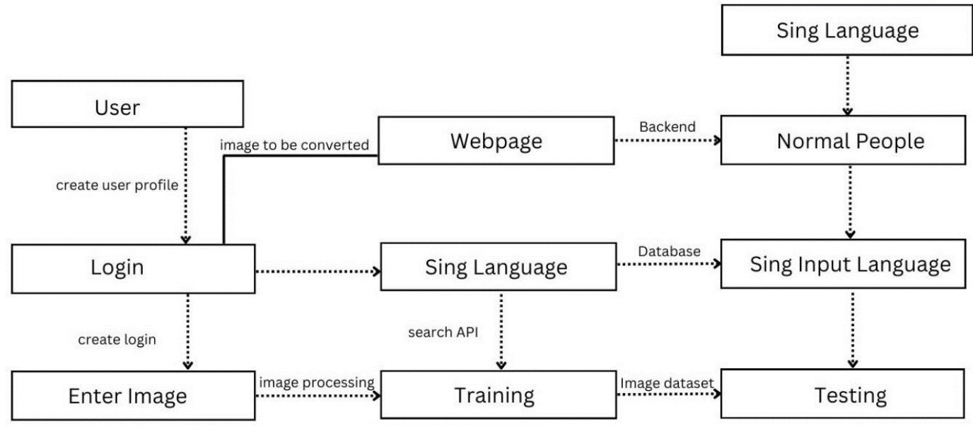

**5.2 Solution & Technical Architecture:**

Technical Architecture (TA) is a technical blueprint with regard to the arrangement, interaction, and interdependence of all elements so that system-relevant requirements are met.

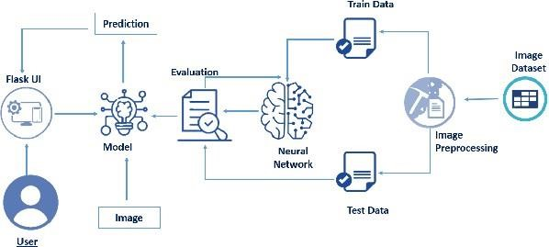

Table: Components & Technologies:

|  |  |  |  |
| --- | --- | --- | --- |
| **S.No** | **Component** | **Description** | **Technology** |
| **1.** | User Interface | Chat bot user interface | HTML, CSS, Python. |
| **2.** | Application Logic | Logic for a process in the application | Python |
| **3.** | Application Logic | Logic for a process in the application | IBM Watson STT service & TTS service |
| **4.** | Cloud Database | Database Service on Cloud | IBM cloudant |
| **5.** | File Storage | File storage requirements | Local File system |
| **6.** | Machine Learning Model | Neural Networks –CNN model, ANN model | Object Recognition Model –CNN model |
| **7.** | Infrastructure (Server / Cloud) | Application Deployment on Local System | Local, Cloud Foundry, Kubernetes |
| **8.** | External Interfaces | Any interface that is transmitting information from the product to a third-party may contain information  that is useful for an attack | Operating System - Windows, Mac, Linux; CPU & GPU (for training), WebCam  Scanners,  Speakers and PC |

**5.3 User stories:**

|  |  |  |  |  |  |  |
| --- | --- | --- | --- | --- | --- | --- |
| **User Type** | **Functional**  **Requirement (Epic)** | **User**  **Story**  **Number** | **User Story/ Task** | **Acceptance**  **Criteria** | **Priority** | **Release** |
| Customer | Registration | USN-1 | As a user, who | I can access | High | Sprint-1 |
| (Low |  |  | has trouble | my |  |  |
| Vision) |  |  | reading due to | account/dash |  |  |
|  |  |  | low vision, I want to be able to market the text larger on the screen so that I can read it. | board |  |  |
| Customer |  | USN-2 | As a user, who | I can receive | High | Sprint-1 |
| (Color |  |  | is color blind, I | confirmation |  |  |
| blindness) |  |  | want to have | email |  |  |
|  |  |  | access to | and click |  |  |
|  |  |  | information conveyed in color so that I do not miss anything and I understand the content. | confirm |  |  |
| Customer |  | USN-3 | As a user, who | I can register | High | Sprint-2 |
| (Impaired |  |  | is hearing - | and |  |  |
| User) |  |  | paired, i want a | access the |  |  |
|  |  |  | transcript of | dashboard |  |  |
|  |  |  | the spoken | with |  |  |
|  |  |  | audio so that I | facebook |  |  |
|  |  |  | can have access to all information provided in audio clips | login |  |  |

## 6.PROJECT PLANNING & SCHEDULING

### 6.1 Sprint Planning & Estimation

|  |  |  |  |
| --- | --- | --- | --- |
| **Milestone** | **Function (Epic)** | **Milestone**  **Story**  **Number** | **Story / Task** |
| Milestone 1 | Data Collection | M1 | We’re collecting dataset for building our project and creating to folders, one for training and another one for testing |
| Milestone 2 | Image Processing | M2 | Importing image data generator libraries and applying image data generator functionally to train the test set. |
| Milestone 3 | Building Model | M3 | Importing the model building libraries, Insulation the model,  Adding Convolution layers,  Adding the Polling layers,  Adding the Flatten layers, Adding Dense layer, Compiling the model Fit and Save the model. |
| Milestone 4 | Testing Model | M4 | Import the packages first. Then we save the model and Load the test image. Pre-progress it and predict it. |
| Milestone 5 | Application layer | M5 | Build the flask application and the HTML pages. |
| Milestone 6 | Train Conversation Engine | M6 | Register for IBM cloud and train image classification mode |
| Milestone 7 | Final Result | M7 | To ensure all the activities and resulting the final output. |

**6.2 Sprint Delivery Schedule**

### Product Backlog, Sprint Schedule, and Estimation

|  |  |  |  |  |  |  |
| --- | --- | --- | --- | --- | --- | --- |
| **Sprint** | **Functional Requirement**  **(Epic)** | **User**  **Story**  **Numb**  **er** | **User Story / Task** | **Stor y**  **Poin**  **ts** | **Priori ty** | **Team Members** |
| Sprint  t-1 | Data  Collection | USN-1 | Dataset is collected on the basis of various hand signs and curated according to the problem statement. | 4 | High | R. saranya  A. selvathi  G. yogeshwari  B.Rajeshwari |
| Sprin  t-1 | Data Pre-processing ng | USN-2 | The dataset  is  pre-processes d in order to check noisy data and other inconsistence ies before executing it to the algorithm | 6 | Medium m | R. saranya  A. selvathi |
| Sprin  t-2 | Model Building | USN-3 | Model is built according to the image  features in such a way  that the model  identifies the features of the sign image and learns in order to give correct output. | 8 | High | R. saranya  G.yogeshwari |
| Sprin  t-3 | Model Training | USN-4 | Data is fed into the model and the model is trained in order to find the optimal weights that give help in predicting the correct output. | 8 | Medium m | A. selvathi  B. Rajeshwari  Yogeshwari |
| Sprin  t-3 | Training and Testing | USN-5 | Model is tested in such a way that the collection data or images are trained frame by frame according to the user requirement  s. | 6 | High | R.Saranya |
| Sprin  t-4 | Implementation  of the application | USN-6 | Converting the input sign language images into English alphabets | 8 | Medium | R. Saranya  A. Selvathi  B. Rajeshwari  G .Yogeshwari |

**Project Tracker, Velocity & Burn down Chart:**

|  |  |  |  |  |  |  |
| --- | --- | --- | --- | --- | --- | --- |
| **Sprint** | **Total Stor y**  **Poin**  **ts** | **Duration on** | **Sprint Start Date** | **Sprint**  **End**  **Date (Planned**  **d)** | **Story**  **Points**  **Complete d (as on Planned**  **End Date)** | **Sprint**  **Release**  **Date**  **(Actual)** |
| Sprint-1 | 20 | 6 Days | 24 Oct 2022 | 29 Oct 2022 | 20 | 29 Oct 2022 |
| Sprint-2 | 20 | 6 Days | 31 Oct 2022 | 05 Nov 2022 | 20 | 05 Nov 2022 |
| Sprint-3 | 20 | 6 Days | 07 Nov 2022 | 12 Nov 2022 | 20 | 12 Nov 2022 |
| Sprint-4 | 20 | 6 Days | 14 Nov 2022 | 19 Nov 2022 | 20 | 19 Nov 2022 |

**Velocity:**

Imagine we have a 10-day sprint duration, and the velocity of the team is 20 (points per sprint). Let’s calculate the team’s average velocity (AV) per iteration unit (story points per day)

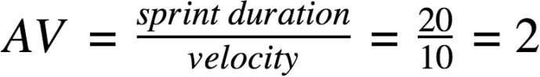

**Burn down Chart:**

A burn down chart is a graphical representation of work left to do versus time.

It is often used in agile [software development m](https://www.visual-paradigm.com/scrum/what-is-agile-software-development/)ethodologies such as [Scrum.](https://www.visual-paradigm.com/scrum/scrum-in-3-minutes/) However, burn down charts can be applied to any project containing measurable progress over time.



1

8

1

6

1

4



Sprint

4

Sprint

3



4

2



day



day



day



day



day



day6

# 7.CODING & SOLUTIONING

## 7.1 Feature

The project is the flask application for converting hand signs to speech. Home page has a record button. By pressing the button, the hand signs will be read from the camera. In the backend, the classifier converts the hand sign to the respective character. The converted character is displayed on the screen. On pressing Esc button, the audio of the shown hand sign will be played.

The file asl_classifier.h5 contains the model for converting hand signs to text. The model is loaded using the keras library, keras. models.load_model. lables_dict maps the model's output to the alphabets.

Python provides various libraries for image and video processing. One of them is OpenCV. OpenCV is a vast library that helps in providing various functions for image and video operations. With OpenCV, we can capture a video from the camera. It lets you create a video capture object which is helpful to capture videos through a webcam and then you may perform desired operations on that video.

**Steps to capture a video:**

Use cv2.VideoCapture() to get a video capture object for the camera.

Set up an infinite while loop and use the read () method to read the frames using the above created object. Use cv2.imshow() method to show the frames in the video.

Breaks the loop when the user clicks a specific key.

There are several APIs available to convert text to speech in Python. One of such APIs is the Google Text to Speech API commonly known as the gTTS API. gTTS is a very easy to use tool which converts the text entered, into audio which can be saved as a mp3 file. The gTTS API supports several languages including English, Hindi, Tamil, French, German and many more. gtts is used in the project to convert the text to speech.

## 8. TESTING

### 8.1 Test Cases

Test cases are the hand signs for each alphabet

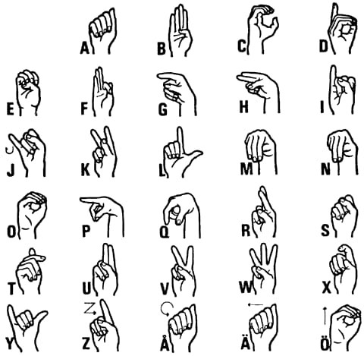

#### 8.2 User Acceptance Testing

**User Acceptance Testing (UAT)** is a type of testing performed by the end user or the client to verify/accept the software system before moving the software application to the production environment. UAT is done in the final phase of testing after functional, integration and system testing is done.

#### Purpose of UAT

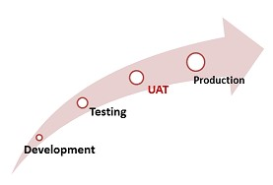

The main **Purpose of UAT** is to validate end to end business flow. It does not focus on cosmetic errors, spelling mistakes or system testing. User Acceptance Testing is carried out in a separate testing environment with production-like data setup. It is kind of black box testing where two or more end-users will be involved. **Need of User Acceptance Testing**

**Need of User Acceptance Testing** arises once software has undergone Unit, Integration and System testing because developers might have built software based on requirements document by their own understanding and further required changes during development may not be effectively communicated to them, so for testing whether the final product is accepted by client/end-user, user acceptance testing is needed.

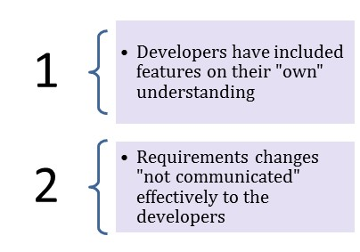

Developers code software based on requirements document which is their “own” understanding of the requirements and **may not actually be what the client needs from the software**.

Requirements changes during the course of the project may not be communicated effectively to the developers.

## 9. RESULTS

### 9.1 Performance Metrics

The accuracy of the model is 0.96 by training the with the epoch of 10.

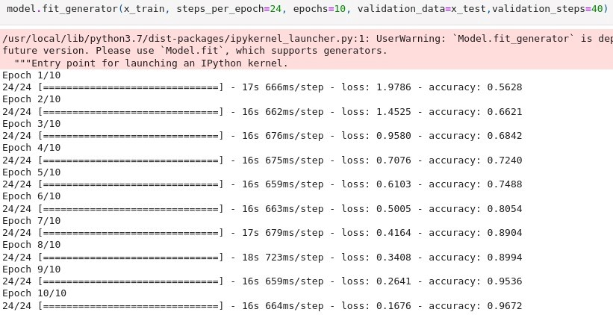

We are making use of a convolution neural network to create a model that is trained on different hand gestures. An app is built which uses this model. This app **enables deaf and dumb people to convey their information using signs which get converted to humanunderstandable language and speech is given as output**.

10. ADVANTAGES & DISADVANTAGES

### 10.1 Advantages

It helps to listen to class notes, text books and electronic text.

➨It facilitates education.

➨It avoids eyestrain from too much reading.

➨It helps in learning languages which you do not know.

➨It helps in preparation of speeches by hearing your work read aloud.

➨It helps in listening e-books or e-material during journey.

➨It amuses children by letting your PC read stories to them when you are busy.

➨It helps seniors or those having vision problems.

➨It can be adapted easily to say whatever users want them to say.

➨It can help in reading large paragraphs and offers range of different accents and voices.

#### 10.2 Disadvantages

➨The system is very time consuming as it requires huge databases and hard-coding of combination to form these words. As a result speech synthesis consumes more processing power.

➨The resulting speech is less than natural and emotionless. This is because it is impossible to get audio recordings of all possible words spoken in all the possible combinations of emotions, prosody, stress etc.

➨Pronunciation analysis from written text is a major concern.

➨It is difficult to build a perfect system.

➨Filtering background noise is a task which can even be difficult for humans to accomplish.

11. CONCLUSION

**AI holds the key to unlocking a magnificent future where, driven by data and computers that understand our world, we will all make more informed decisions**. These computers of the future will understand not just how to turn on the switches but why the switches need to be turned on.

The project aims at converting sign gestures into speech that can be understood by normal people. The entire model pipeline is developed by CNN architecture for the classification of 26 alphabets and one extra alphabet for null character. The model has achieved an efficiency of 96.08% .

## 12. FUTURE SCOPE

Model enhancement could bring better accurate values. It takes nearly 3 seconds for the model to predict the hand signs. A better model could be used to predict the hand signs in few milliseconds.

We are making use of a **convolution neural network to create a model that is trained on different hand gestures**.

**13. APPENDIX Source Code:**

!pip install keras

! pip install tensor flow! pip install opencv-python import cv2

from keras. Models import load model from tensor flow. keras. utils import loading, img_to_array # from keras. pre-processing. image import loading, img_to_array import numpy as np import tensor flow as tf import keras

model = keras. models. load model("asl_classifier.h5") labels_dict = {0:'0',

1:'A',

2:'B',

3:'C',

4:'D',

5:'E', 6:'F',

7:'G', 8:'H',

9:'I',

10:'J',

11:'K',

12:'L',

13:'M',

14:'N', 15:'O',

16:'P',

17:"Q",

18:'R', 19:'S',

20:'T',

21:'U',

22:'V',

23:'W',

24:'X',

25:'Y',

26:'Z'}

color_dict=(0,255,0) x=0 y=0 w=64 h=64

**Fully Real-Time:** img_size=128 minValue = 70 source=cv2.VideoCapture(0) count = 0 string = " " prev = " " prev_val = 0 while(True):

ret, imp=source. Read () gray=cv2.cvtColor(img, cv2.COLOR_BGR2GRAY)

#cv2.rectangle(img,(x,y),(x+w,y+h),color_dict,2) cv2.rectangle(img,(24,24),(250 , 250),color_dict,2) crop_img=gray[24:250,24:250] count = count + 1 if(count % 100 == 0): prev_val = count cv2.putText(img,str(prev_val//100),(300,150),cv2.FONT_HERSHEY_SIMPLEX,1.5,(

255,255,255),2) blur = cv2.GaussianBlur(crop_img, (5,5),2)

th3=cv2.adaptiveThreshold(blur,255,cv2.ADAPTIVE_THRESH_GAUSSIAN_C,cv2.T HRESH_BINARY_INV,11,2)

ret,res=cv2.threshold(th3,minValue,255,cv2.THRESH_BINARY_INV+cv2.THRESH_ OTSU)

resized=cv2.resize(res, (img_size, img_size)) normalized=resized/255.0 reshaped=np. reshape (normalized, (1, img_size, img_size,1)) result = model. Predict(reshaped)

#print(result)

label=np. argmax (result, axis=1) [0] if (count == 300): count = 99 prev= labels_dict[label]

if (label == 0):

string = string + " "

#if(Len(string)==1 or string[Len(string)]! = " "):

else:

string = string + prev

cv2.putText(img, prev, (24,14), cv2.FONT_HERSHEY_SIMPLEX,0.8,(255,255,255),2) cv2.putText(img,string,(275,50),cv2.FONT_HERSHEY_SIMPLEX,0.8,(200,200,200),

2)

cv2.imshow("Gray”, res) cv2.imshow('LIVE’, img) key=cv2.waitKey(1)

if(key==27): #press Esc. to exit break print(string)

cv2.destroyAllWindows() source. Release ()

cv2.destroyAllWindows()

!pip install gTTS

! pip3 install --upgrade setup tools

! pip3 install play sound pip install play sound from gtts import gTTS import play sound

# This module is imported so that we can

# play the converted audio import os

# The text that you want to convert to audio

# Language in which you want to convert language = 'en'

# Passing the text and language to the engine,

# here we have marked slow=False. Which tells

# the module that the converted audio should

# have a high speed

mob = gTTS (text=string, Lang=language, slow=False)

# Saving the converted audio in a mp3 file named

# welcome myobj. save("welcome.mp3")

# Playing the converted file play sound. Play sound("welcome.mp3") from play sound import play sound play sound('welcome.mp3')

**GitHub Link:**

https://github.com/Rsaranyas/IBM-Project-14129-1659542042.git